## SSO Documentation: Keycloak and Java JDK Setup

### Keycloak Setup

1. **Download Keycloak**
   * Visit the [Keycloak Downloads](https://www.keycloak.org/downloads) page.
   * Download Keycloak version 25.0.5:
     + Choose either the ZIP (SHA1) or TAR.GZ (SHA1) file.
2. **Extract the Downloaded File**
   * Extract the contents of the downloaded file to a location of your choice.
3. **Run Keycloak in Development Mode**
   * Open a Command Prompt window.
   * Navigate to the bin directory within the extracted Keycloak folder. For example:

C:\Users\user\Downloads\keycloak-25.0.5\bin

* + You can open Command Prompt directly in this path by typing cmd in the address bar of the File Explorer window and pressing Enter.
  + Start Keycloak in development mode by running the following command:

bin\kc.bat start-dev

if the java jdk is not found or java_HOME setup is not found , then setup the java jdk setup by the following given below step.

### Java JDK Setup

If Java JDK is not already installed on your system, follow these steps:

1. **Download Java JDK**
   * Download the Java JDK 22 x64 Installer from the following link: [jdk-22_windows-x64_bin.exe](https://download.oracle.com/java/22/latest/jdk-22_windows-x64_bin.exe).
2. **Install Java JDK**
   * Run the downloaded installer and follow the on-screen instructions to complete the installation.
3. **Set Up JAVA_HOME and Update PATH**
   * Open the Environment Variables settings:
     + Press Windows Key and search for “Environment Variables”.
     + Click on “Edit environment variables for your account”.
   * In the Environment Variables window:
     + **Add JAVA_HOME Variable:**
       - Under the "User variables" section, click “New”.
       - Set the variable name to JAVA_HOME and the variable value to the path of the Java JDK installation, e.g., C:\Program Files\Java\jdk-22.
       - Click “OK”.
     + **Update PATH Variable:**
       - In the "User variables" section, find and select the Path variable, then click “Edit”.
       - Click “New” and add %JAVA_HOME%\bin.
       - Click “OK” to save the changes.
   * Verify the Java JDK installation:
     + Open a new Command Prompt window and run:

java --version

* + - You should see the version information for Java JDK 22.

1. After setting up Java JDK, go back to the Keycloak bin directory and run the following command to start Keycloak in development mode:

bin\kc.bat start-dev

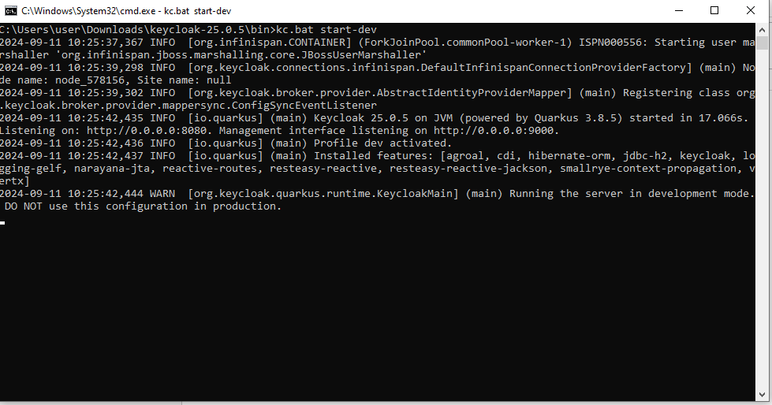

After this step   
Go to browser and type “ <http://localhost:8080/> “

It will give the option for registration for new user , after registration login using that account.